IV Semester PBL Report

PASSWORD MANAGER

BY

N.Sai Asvitha Reddy 20641A66A7
P.Sumanya 20641A66B7
J.Bharadwaj 20641A6671
M.Rishitha 20641A6689

Under the Guidance of

Mrs.V.Prasanthi mam
Asst Prof.



DEPARTMENT OF COMPUTER SCIENCE & ENGINEERING (AI & ML)
VAAGDEVI COLLEGE OF ENGINEERING
(UGC Autonomous, Accredited by NBA, Accredited by NAAC with “A”)
Bollikunta, Khila Warangal (Mandal), Warangal Urban-506 005 (T.S)

VAAGDEVI COLLEGE OF ENGINEERING
(UGC Autonomous, Accredited by NBA, Accredited by NAAC with “A”)
Bollikunta, Khila Warangal (Mandal), Warangal Urban-506 005 (T.S)
DEPARTMENT OF COMPUTER SCIENCE & ENGINEERING (AI & ML)



CERTIFICATE

This is to certify that the project work carried out by N.Sai_Asvitha Reddy(20641A66A7),M.Rishitha_Reddy(20641A6689),P.Sumanya(20641A66B7),J.Bharadaj(20641A6671)is considered as part of the Project Based Learning in the 4th semester of B.Tech Computer Science and Engineering (AI &ML) during the academic year 2021-22.

Guide Head of the Department External Examiner

INDEX

TOPIC Page No
ABSTRACT: 04
INTRODUCTION: 05
ALGORITHM: 06
ADVANTAGES 07
HARDWARE AND SOFTWARE REQUIREMENTS: 08
MODULES USED: 09
PROJECT CODE: 10
OUTPUT: 14
CONCLUSION: 15
BIBLIOGRAPHY: 16

ABSTRACT
Password managers protect uses password by using a master password or a security token. The security of them using master password is weaken if users use weak master password. Password managers reduce the difficulties in creating and remembering strong passwords. Password is the most popular and simplest way in which users can authenticate themselves before accessing computer systems or websites. Password management is organisation and encryption of many personal password using a single login. Some common risk involved in losing password is over the shoulder attack, brute force attack, sniffing attack, login spoofing attack. This ensures that it provides security from hackers as well as getting rid of remembering passwords.
Even if some companies are supposed to scramble our password once we enter it known as hashing, not all of them use powerful or modern algorithms, making it simple for hackers to reverse hashing and read or password is plain test. others don’t care at all about hashing. Using a password manager makes it much easier to create and store stronger passwords that are unique to each site that prevent credential stuffing attacks

INTRODUCTION
Password managers are applications that serve as the solution for maintaining a large number of passwords and account information. They store the login information of the various accounts and automatically enter them into the forms. This helps in the prevention of hacker attacks like keystroke logging and it prevents the need to remember multiple password. Passwords managers enable the use of strong and unique passwords for each online account and provide an efficient way to manage all the passwords. The login information is encrypted and stored in either the local memory of the user’s system or in cloud storage. Portable password manager applications installed in mobile devices can also be used as a way to manage and remember passwords anywhere and use them on shared systems
ALGORITHM
Step:1: start
Step:2: First Install the relevant modules and libraries.
Step:3: Then Import the modules and libraries.
Step:4: The code is executed in the pycharm.
Step:5: After solving errors we compile the code.
Step:6: we get required output
Step:7: stop

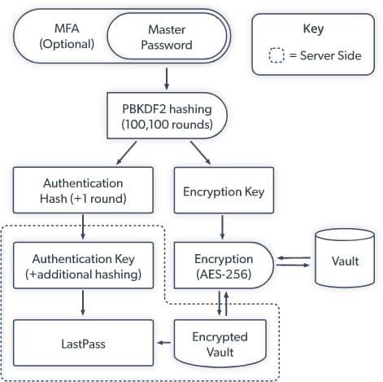

ADVANTAGES

- The main benefit of using a password manager to boost your cyber security is that you don't need to have a good memory.
- That means everyone can incorporate the latest recommendations for secure passwords, including using long phrases, symbols, punctuation, and capitalization .
- Password managers allow people to type a single password, and then have each access point automatically populated with a username and password.
- Your team will spend less time fumbling with login screens and password recovery and spend more time doing what matters.

HARDWARE REQUIREMENTS

- Intel dual core
- 512 MB Ram
- Mouse
- Hard disk 80 GB
- Key board Standard

SOFTWARE REQUIREMENTS
    - Windows 7, 8, 8.1 or 10
    - Python compiler
    - Python 3.9.8
    - SQL

MODULES USED:
- cryptography: A python library that will help us to create new passwords in a secure way.

- IIS App Pool: Supporting for automatically resting password.

- Wikipedia: Wikipedia is used to fetch a variety of information from the Wikipedia website
- Mgnl: provides us a specific node type for the passwords

PROJECT CODE
from cryptography.fernet import Fernet

class PasswordManager:

def _init_(self):
self.key = None
self.password_file = None
self.password_dict = {}

def create_key(self, path):
self.key = Fernet.generate_key()
with open(path,'wb') as f:
f.write(self.key)
def load_key(self, path):
with open(path, 'rb')as f:
self.key=f.read()
def create_password_file(self,path,initial_values=None):
self.password_file = path

if initial_values is not None:
for key, value in initial_values.items():
self.add_password(key,value)

def load_password_file(self,path) :
self.password_file = path

with open(path, 'r') as f:
for line in f:
site,encrypted = line.split(":")
self.password_dict[site] = Fernet(self.key).decrypt(encrypted.encode())
def add_password(self, site, password):
self.password_dict[site] = password

if self.password_file is not None:
with open(self.password_file, 'a+') as f:
encrypted = Fernet(self.key).encrypt(password.encode())
f.write(site + ":" + encrypted.decode() + "\n")
def get_password(self, site):
return self.password_dict[site]
def main():
password = {
"email": "1234567",
"facebook": "myfbpassword",
"youtube": "helloworld123",
"something": "myfavoritpassword_123"
}

pm = PasswordManager()
print("""What do you want to do?
(1) Create a new key)
(2) Load an existing key
(3) Create new password file
(4) Load existing password file
(5) Add a new password
(6) Get a password
(q) Quit
""")

done = False

while not done:

choice = input("Enter your choice: ")
if choice == "1":
path = input("Enter path: ")
pm.create_key(path)
elif choice == "2":
path = input("Enter path: ")
pm.load_key(path)
elif choice == "3":
path = input("Enter path: ")
pm.create_password_file(path, password)
elif choice == "4":
path = input("Enter path: ")
pm.load_password_file(path)
elif choice == "5":
site = input("Enter the site: ")
password = input("Enter the password: ")
pm.add_password(site, password)
elif choice == "6":
site = input("What site do you want: ")
print(f"Password for { site } is { pm.get_password(site)}")
elif choice == "q":
done = True
print("Bye")
else:
print("Invalid choice!")

if _name_ == "_main_":
main()
OUTPUT

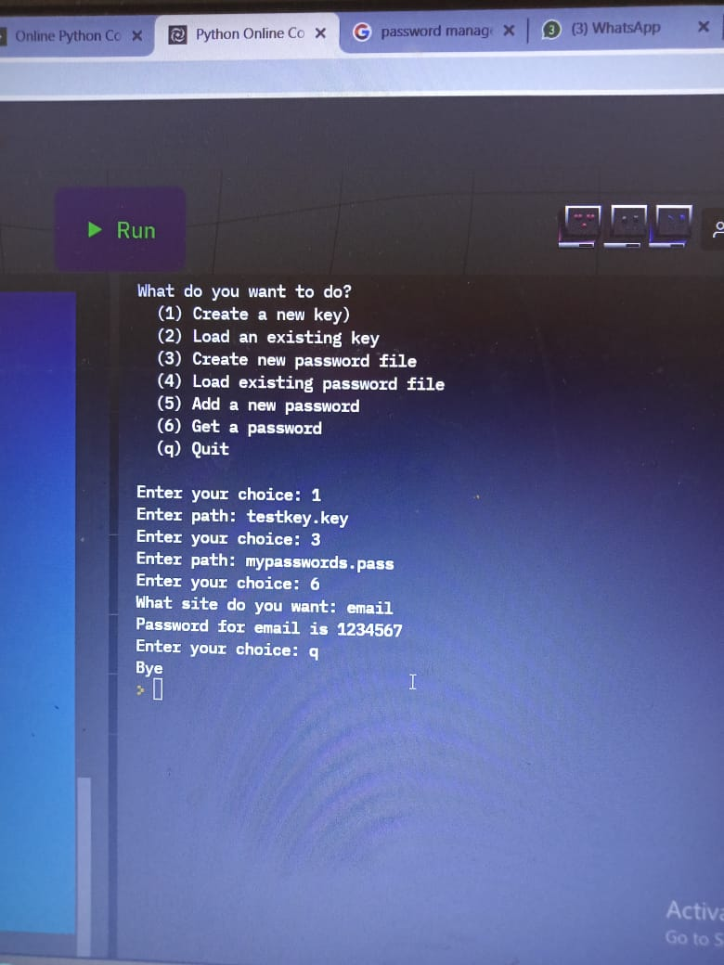

CONCLUSION

This is simple Password Management System graphical user interface developed using visual Basic. It allows the user to add account information for different accounts he holds on the internet. Password Management System basically stores the user name and password details in an encrypted format in the database. The encryption is managed by blow fish algorithm. The user has to login to the system. It checks for the validity of the user. The user shall be able to add account. The user can add user name and password details and save to the database. The list of accounts held by the user is displayed on the left screen. We conclude that by this we have many advantages.

BIBLIOGRAPHY:
- Python GUI Programming with Tkinter: Design and build functional and user-friendly GUI applications, 2nd Edition .Author : Alan D. Moore
- Delphi GUI Programming with FireMonkey ,Author: Andrea Magni
- Modern Tkinter for Busy Python Developers ,Author:Mark Roseman

